AWS OpenSearch Service (Provisioned) – Component Standard

Version | : | 1.0 ARB Approved
Date | : | 2026-04-23
Author | : | Ashish.tiwari@aegon.com
Version control
Version | Date | Author/updated by | Comments
0.01 | 2026-04-07 | Ashish Tiwari | First Draft
0.02 | 2026-04-17 | Ashish Tiwari | Updates based on review comments
0.03 | 2026-04-24 | Ashish Tiwari | Added namespace details
1.0 | 2026-04-24 | Ashish Tiwari | Release Verison.

Note:
Versions: 0.XX Pre-release, n.XX Release, n.XX.xx draft releases of version under version control
Contents
Distribution and Contacts 4
Artifacts 5
Overview 6
Drivers and Motivation 6
Business Value 7
Considerations 8
Functionality / How it Works 10
Architectural Attributes 11
User Access & Roles 12
Use Cases 13
Data & Governance 14
Data Classification 14
Guardrails 14
Capabilities and Product Comparison 15
Capability Table 15
Exceptions 16
Related links to other architectural documents used at Aegon 17
Related Component Standards 17
Architectural Patterns 17
Reference Architecture 17
Solution Architectures 18

Distribution and Contacts
ISO, DPO and Architects - GTS Architecture Solution Design - Global IT Confluence Production (aegon.com)
This document and future updates to be shared with the business representatives shown below.
Business Contacts and Information
Requester | Ashish Tiwari
Business DPO
Business ISO
Business Architect | Graeme Rankin
BCP Manager
Business Unit
Cost Center
Cost Center Owner
Product / Service Owner | David Allaway
GTS Contacts and Information
GTS DPO | Adam Kaminski & Emma Warner
GTS ISO | David Innes, Nick Russell & Daniel Lartey
GTS Architecture | Neil Everest
GTS Technology Risk Assessment | Rachel Singewald, Matyas Vajda
GTS/Corp Centre GenAI Working Group | Guy Dye

Artifacts
Review Process and Acknowledgements
In Scope | Owner | Non-Architecture Review / Assessment Process | Point of Contact | Link to Acknowledgement or Evidence
☐ | First Line Risk & Controls | Technology Risk Assessment (only for Core and Common designs) | Rachel Singewald, Juan Irizarry | Link
☐ | GTS – Information Security | Information Security Review (process in development and will replace security review section) | Nick Russel, Daniel Lartey | Link
☐ | GTS – Information Security | Threat Model | Paul Nickelson, Jeff Bain | Link
☒ | Data Privacy | Data Privacy Impact Assessment (OneTrust) | Adam Kaminski | DPIA 13515
☒ | GTS - Architecture | Approved Architectural Artifacts Added to Architecture Repository | Neil Everest | Link to Repo
☐ | GTS/Corp Centre GenAI | GenAI Inventory & Working Group Communication | Guy Dye | GenAI Inventory ID

Architecture review checklist
Role | Name | Status
Infrastructure Architect |  | Not read
Enterprise Architect |  | Not read
Solution Architect | Alvin Lee | Approved
Security Architect |  | Not read

Stakeholders review checklist
Role | Name | Status
GTS DPO | Adam Kaminski or Emma Warner | Not read
GTS ISO | Nick Russell or Daniel Lartey | Not read
GTS Technology Risk Assessment | Rachel Singewald or Juan Irizarry | Not read
Cloud Infrastructure | John Drummond or John Hegyi | Not read

Overview
AWS OpenSearch Service (Provisioned) is a fully managed search and analytics service based on the OpenSearch engine, used to ingest, index, search, and visualize large volumes of structured and unstructured data.

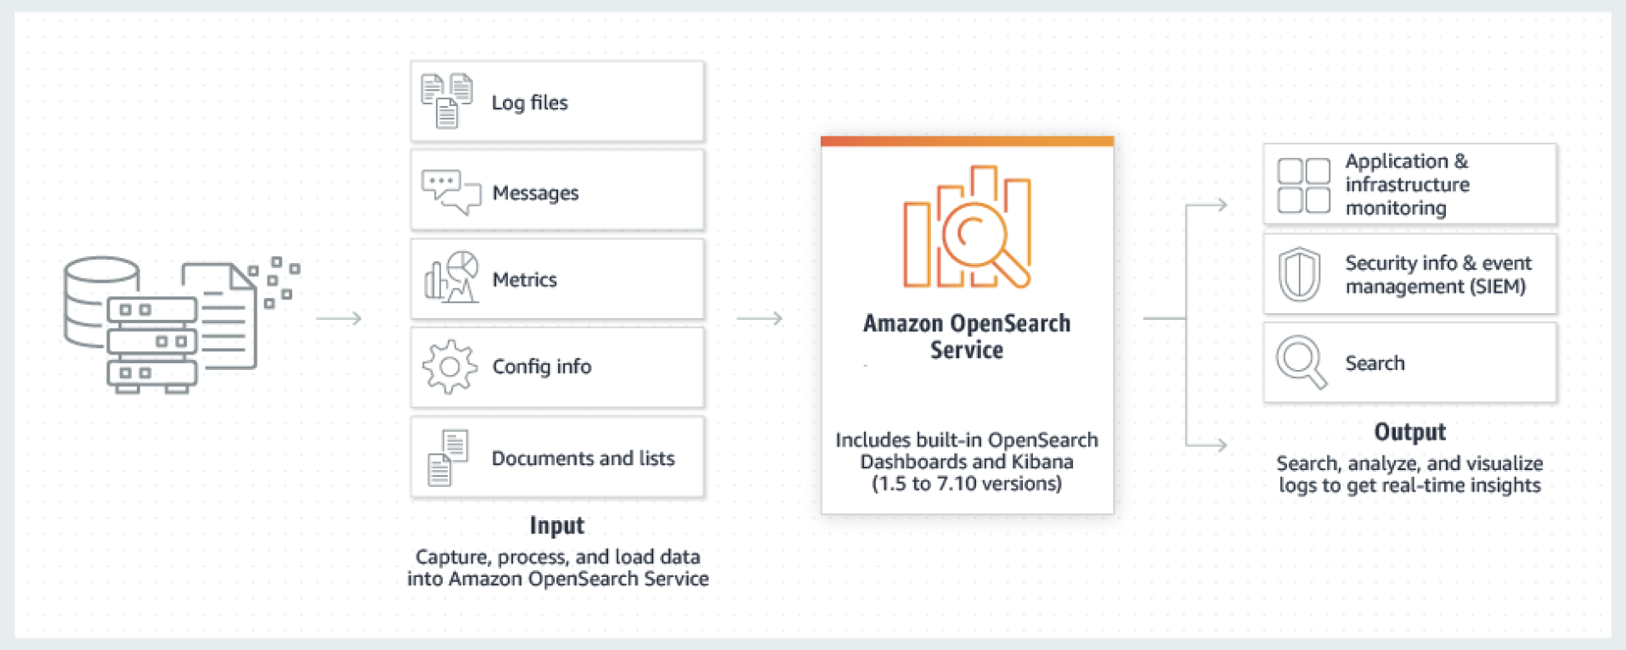
Within Aegon, AWS OpenSearch (Provisioned) is intended for enterprise-grade workloads that require:
- Predictable performance
- Dedicated capacity
- Fine-grained security controls
- Integration with AWS-native logging, monitoring, and analytics services
This component standard defines the approved, secure, and compliant use of AWS OpenSearch Service (Namespace – Opensearch service (es*) in a provisioned cluster configuration.

Drivers and Motivation
Aegon applications require secure, resilient, and scalable search capabilities to support core business functions such as document retrieval, case management, and operational reporting. Embedded or self‑managed search solutions increase operational overhead, create tight coupling with application platforms, and do not align well with cloud‑native and containerised architectures.
AWS OpenSearch Service (provisioned) is adopted to provide a centrally managed, enterprise‑grade search platform that aligns with Aegon’s cloud, security, and resilience standards. Externalising search enables consistent implementation across multiple technology stacks, reduces operational risk, and supports predictable performance and controlled scaling for regulated workloads.
Platforms such as Aegon UK’s Pega use this pattern, having transitioned away from embedded search in favour of externalised search services, making AWS OpenSearch Service an appropriate and reusable organisational standard.

Business Value
- Operational efficiency: Reduces overhead of managing search infrastructure
- Cost transparency: Predictable pricing through provisioned node types
- Security & compliance: Native IAM, VPC isolation, encryption, and audit logging
- Reliability: Managed backups, multi-AZ deployments, and automated patching

Considerations
Security Considerations
- Deploy the domain within a VPC only and remove public endpoints to eliminate internet exposure.
- Enable fine-grained access control (FGAC) and integrate it with IAM roles and policies for authentication and authorization.
- Block anonymous access and require all requests to authenticate through IAM, SAML, or Cognito.
- Encrypt data at rest using AWS KMS–customer managed keys (CMK).
- Enforce TLS encryption for all client connections in transit.
- Enable node-to-node encryption to protect inter-node traffic.
- Capture audit logs (security, index, and search events) and ship them to CloudWatch Logs.
- Enforce least-privilege IAM policies for domain access and snapshot roles.
Cost Optimization
- Right-size data nodes and dedicated master nodes based on indexing rate, query volume, and data retention requirements.
- Avoid over-sharding
- Use UltraWarm and cold storage tiers for infrequently accessed or historical data.
- Apply Index State Management (ISM) policies for index rollover, warm/cold transitions, and deletion.
- Conduct regular cost and utilization reviews, focusing on shard count, index size, and node utilization.
Operational Excellence
- Use Infrastructure as Code (IaC) with Terraform to produce repeatable and auditable deployments.
- Automate index lifecycle management using ISM and rollover policies.
- Centralize observability through CloudWatch metrics, logs, and OpenSearch Dashboards, feeding into Aegon standard observability tooling (Splunk/Neptune)
- Enable slow logs for indexing and search queries to support troubleshooting.
- Maintain documented SOPs and runbooks for index operations, scaling, upgrades, and incident response.
Reliability
- Deploy the cluster across multiple Availability Zones and enable zone awareness to improve availability.
- Use dedicated master nodes in medium and large clusters to maintain cluster stability.
- Create automated daily snapshots and store them in Amazon S3 with defined retention policies.
- Rely on AWS-managed patching and version upgrades during planned maintenance windows.
- Configure alarms and proactive cluster health monitoring.
Performance Efficiency
- Select instance families based on workload characteristics:
  - Choose I/O-optimized instances for heavy indexing workloads.
  - Choose compute-optimized instances for query-heavy workloads.
- Enforce shard sizing guidelines, generally maintaining 10–50 GB per shard for hot data.
- Implement hot–warm or hot–warm–cold architectures where data access patterns vary.
- Monitor query and indexing performance continuously and tune refresh intervals and replica counts.
- Control field mappings and analyzed fields to prevent excessive JVM heap pressure.
Sustainability
- Use tiered storage (UltraWarm and cold) to minimize always-on compute usage.
- Apply automated index deletion and retention policies to prevent unnecessary data growth.
- Adopt Graviton-based instances where possible to improve price performance and energy efficiency.

Functionality / How it Works
- Data Ingestion
  - Data ingested via Kinesis, Firehose, Logstash, or Fluent Bit
- Indexing
  - Data indexed into OpenSearch indices with defined mappings
- Search & Analytics
  - Users query data using OpenSearch Dashboards, REST APIs, or applications
- Monitoring
  - Cluster health, storage, and performance monitored via CloudWatch and Neptune
- Retention
  - Lifecycle policies manage data aging and deletion

Architectural Attributes
Interfaces
- Protocols: HTTPS (REST API)
- Authentication: IAM, fine-grained roles
- Data Formats: JSON documents
- Integration: CloudWatch, Kinesis, S3, Lambda
Redundancy, Availability & Reliability
- Multi-AZ deployment supported
- Dedicated master nodes recommended for production
- Automated snapshots to S3
- AWS SLA-backed managed service
Scale, Elasticity & Capacity
- Vertical scaling via node resizing
- Horizontal scaling via additional data nodes
Cost, Business & Support Models
- Charged for instance hours, storage, and data transfer. Pricing depends on the instance type and storage tier
- AWS support via standard Aegon AWS support agreement

User Access & Roles
Typical Roles
- Admins: Cluster configuration, upgrades, security
- Platform Teams: Index and lifecycle management
- Developers: Read/write access to specific indices
- Auditors: Read-only access to logs and dashboards
Federated Roles
- Access via corporate IdP using IAM SSO
Access Control Policies
- IAM-based access
- Index-level permissions can be enforced
- Principle of least privilege mandatory
Restrictions
- Public access not permitted
- No storage of unapproved data classifications
Permitted Regions
- Approved AWS regions only (e.g. eu-west-1 & US East)
- Data residency requirements apply

Use Cases
Use Case One – Externalised Search
Where application require search functionality as a core capability for indexing and retrieving application data and documents. An externalized OpenSearch service is used to index the content, including cases, work objects, attachments, and associated metadata, enabling efficient full‑text search, filtering, and querying without impacting the applications platform performance. Externalizing via OpenSearch allows the search platform to scale independently of the application, providing improved resilience, performance, and operational efficiency as data volumes and usage grow.

https://aws.amazon.com/opensearch-service/

Data & Governance

Data Classification
AWS OpenSearch (Provisioned) may process:
- Internal
- Confidential
- PII – Allowed only with encryption and approval
- Strictly Confidential (unless exception granted)
All data handling must comply with ITCF and data residency policies.
Data classification is depended on the service / solution that is using the component standard and an assessment needs to be done for each implementation.

Guardrails
Network Guardrail
- VPC-only access
- Security groups restricted to approved sources
Security Guardrail
- Encryption at rest (KMS) mandatory
- TLS in transit enforced
- Audit logging always enabled
Data Guardrail
- Retention and deletion policies must be configured
- No long-term storage without business justification

Capabilities and Product Comparison

Capability Table
A table of capabilities of this component with a description and some indication of the weight of the capability used for the selection of the overall component.
Capability | Description | Requirement
Search & query engine | Full-text, fuzzy, structured, and geo-spatial search with low latency | Fast, relevant search beyond traditional databases
Real-time analytics | Near real-time indexing with rich aggregations and metrics | Immediate analytical insights on live data
Scalability & availability | Distributed shards, replicas, and multi-AZ deployments | Handle growing data volumes with high availability
Log & event analysis | Optimized for time-series logs, metrics, and events | Centralized observability and monitoring
Managed operations | AWS manages scaling, patching, backups, and recovery | Low operational overhead
Security & governance | IAM integration, fine-grained access control, encryption | Enterprise security and compliance
Visualization & integration | Dashboards plus native AWS integrations (S3, Kinesis, CloudWatch) | Seamless analytics and visualization in AWS

Exceptions
AWS OpenSearch (Provisioned) should not be used when:
- Workloads are highly spiky and unpredictable (consider Serverless)
- Simple log storage without querying is sufficient (use S3)
- Data classification exceeds approved limits

Related links to other architectural documents used at Aegon

Related Component Standards
Such as other products in the same category that have Component Standards
- Component Standard name and hyperlink
- Component Standard name and hyperlink

Architectural Patterns
A list of links to Architectural Patterns based on this component.
- https://globalitconfluence.us.aegon.com/display/DSKB/Design+Standards+of+AWS+OpenSearch
- https://globalitconfluence.us.aegon.com/display/GCIT/AWS+OpenSearch+Serverless
- https://docs.aws.amazon.com/opensearch-service/latest/developerguide/bp.html#bp-cost-optimization

Reference Architecture
A list of links to Reference Architectures that consume this component.

- Observability workflow in OpenSearch Service
Reference - https://docs.aws.amazon.com/opensearch-service/latest/developerguide/observability.html#observability-workflow

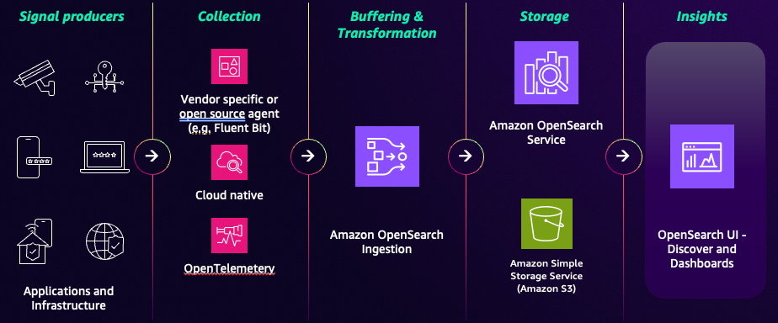

- Search application with Amazon OpenSearch Service
Reference - Creating a search application with Amazon OpenSearch Service - Amazon OpenSearch Service
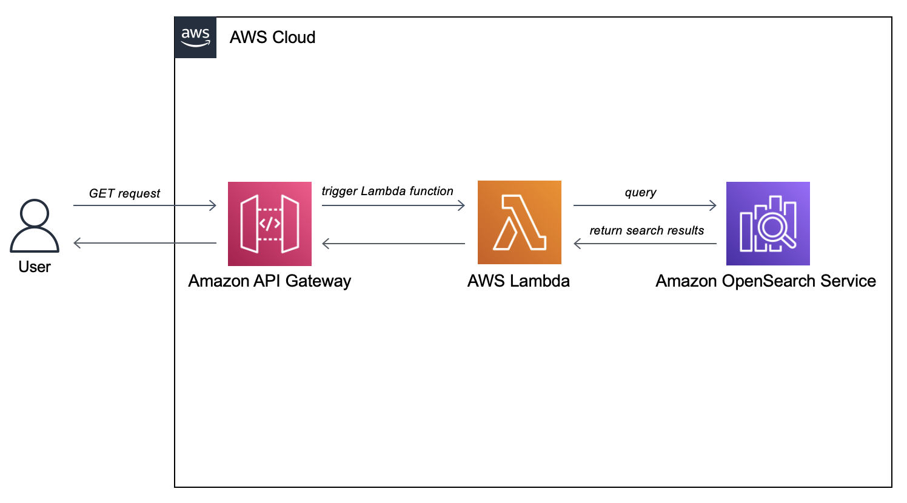

Solution Architectures
A list of links to Solution Architectures that consume this component.

- Pega – will use AWS OpenSearch for Externalised Search Service
Reference -https://globalitconfluence.us.aegon.com/pages/viewpage.action?pageId=847803026

